**SQL Notes**

**Note:-** SQL is not case sensitive

**Creating a table**

**Syntax** : crate table TABLE_NAME(FIELD_NAME-1,FILED_NAME-2,FILED_NAME-3,etc..)

**Inserting values into the table from another value**

**Syntax :** INSERT INTO table_name ( a,b,c) **select** id, name, description from Table_Name;

**--creating a table in DataBase**

create table gouse(a,b,c);

**--detele a table in a database**

drop table gouse;

**--deleting a row from a table**

delete from test__1 where a = 4 ;

select * from test__1;

**--inserting Null values into entire row**

insert into test__1 default values;

**--To perform operation over a filed with NULL value we have to use IS NULL or IS NOT NULL**

select * from test__1 where a IS NULL;

select * from test__1 where a is not null;

**--if you want to create a table which doesn't allow null values in it then fallow below described steps**

create table test__3(a not null,b not null,c not null);

**--creating a table with constrains**

create table gouse(a integer not null, b text not null,c text not null);

insert into gouse values (2,'hello','basha'); # quary will execute successfully

insert into gouse values (null,'gousebasha','bablu');

# throws an error that is [10:08:44] Error while executing SQL query on database 'test': NOT NULL constraint failed: gouse.a

**Which is because we’re not providing any value the field which has not null constrain, To over come this Error we can add DEFAULT constrain to the field while creating the table**

**--creating a table with default constrain**

create table gouse_1(a integer not null default '1st field',

b text not null default '2nd field', c text not null default '3rd field');

insert into gouse_1 (a,c) values (12,"gousebasha");

select * from gouse_1;

**out put of the query will be as shown**

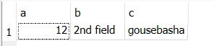

Here even if we don’t provide values to anyone of those filed we won’t get any error, because as have provided default value constrain, we haven’t give any value it will take the value into that particular field which in default constrain

**--adding a column after has been created ( ALTER TABLE TABLE_NAME ADD C_NAME DATA TYPE )**

**--the value of newly added column will be null**

alter table gouse_1 add f text;

**Output:-**

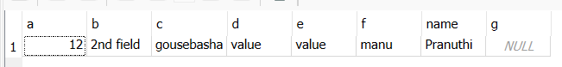

**--The value of newly added field will default value**

alter table gouse_1 add name taxt default "Pranuthi";

**Output:-**

